HSPVA Biology Evolution Test-Review sheet
Evolution:
Natural Selection:
- What are the FOUR steps of natural selection?
- Who is the scientist credited with the theory of biological evolution by means of natural selection?
- What is meant by the term “fitness”?
- How does natural selection produce changes in populations, and not individuals?
- What are two main sources of genetic variation?
- How do mutations and meiosis increase genetic variation?
- How does the development of antibiotic resistant bacteria relate to evolution?

Evidence of Evolution:
- How do the following provide evidence of change in species?
    - DNA sequences
    - anatomical and physiological similarities
    - embryology
    - vestigial structures
- What is artificial selection, and how does it provide evidence of evolution?
- How does the fossil record provide evidence of common ancestry among groups of organisms?
- Provide one definition of evolution.
- Why is the study of evolution important?
- How do mechanisms of evolution change diversity of populations?
- Why do some populations undergo a dramatic increase or decrease in size?

Cladograms:
- What is cladogram and how is it related to evolution?
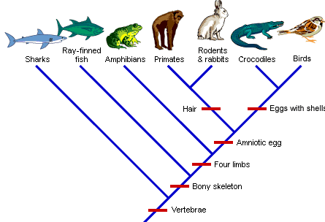
- In the cladogram above, what characteristic is found in ALL species?
- In the cladogram above, what characteristic is ONLY found in crocodiles and birds?
- Based on the cladogram above, which 2 groups are most closely related: sharks and ray-finned fish or crocodiles and birds?

Other Mechanisms of Evolution:
- What is a gene pool?
- What is genetic drift?
- How is genetic drift different from natural selection?
- Genetic drift can occur via a bottleneck or the founder effect. Describe the difference between the two.

