HSPVA Biology Exam III Review Sheet

3.1 | I know that cells are the basic structures of all living things  with specialized parts that perform specific functions.

CELLS:
1.) Label the following diagrams with the following cell structures and organelles: plasma membrane, cytoplasm, Golgi apparatus, nucleus, endoplasmic reticulum (rough and smooth), ribosomes, vacuole, cell wall, chloroplast, and mitochondria

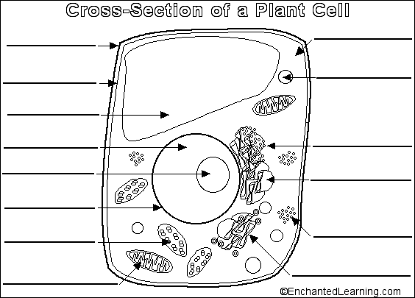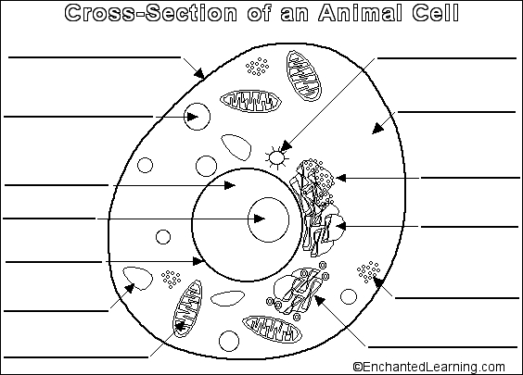
2.) Describe the function of each organelle AND list if it belongs to prokaryotes, plants, or animals:
Nucleus:
Rough endoplasmic reticulum:
Smooth endoplasmic reticulum:
Vacuole:
Cytoplasm:
Plasma membrane:
Cell wall:
Chloroplast:
Mitochondria:

3.2 | I can compare and contrast prokaryotic and eukaryotic cells.

3.) What are the main differences between prokaryotic and eukaryotic cells?

4.) What type of organisms are made of prokaryotic cells? Bacteria protists fungi plants animals

5.) What type of organisms are made of eukaryotic cells? Bacteria protists fungi plants animals

6.) All prokaryotic cells are ___cellular while eukaryotic cells can be ___cellular or ____cellular.

3.3 | I can investigate and explain cellular processes, including homeostasis,  energy conversions, transport of molecules, and synthesis of new  molecules.  I know that biological systems work to achieve and maintain homeostasis.

CELL TRANSPORT:
7.) What is the structure of the plasma membrane?
8.) What is the function of the plasma membrane?
9.) Use the following terms to describe the phosphate heads and the fatty acid tails of the
phospholipid bilayer: polar, nonpolar; hydrophobic, hydrophilic, Phosphate heads, Fatty acid
tails
10.) Draw a sketch of the plasma membrane.
11.) What is diffusion?
12.) What is osmosis?
13.) What will happen to a cell that is placed into a high concentration of salt water and why?
14.) What will happen to a cell that is placed into distilled water and why?
15.) Distinguish between the terms hypotonic, hypertonic, and isotonic.
16.) What will happen to a cell placed in a hypertonic solution and why?
17.) What are 2 similarities and 2 differences between osmosis and diffusion?
18.) Which of the following require the cell to use energy? Diffusion, facilitated, diffusion, osmosis,
active transport
19.) For the egg lab, what were the independent, dependent, and constant variables?
20.) What happened to the egg in syrup and the egg in the water and why? Use the terms
hypotonic and hypertonic.
THE CELL CYCLE:

- What is meant by the cell cycle?
- What is the difference between the cell cycle, cell division, and mitosis?
- What is the function of cell division?
- List 3 types of cells that are going through cell division.
- What are all of the stages of the cell cycle, in order?
- What are the three stages of Interphase in order?
- What happens in G1?
- What happens in the S phase?
- What happens in G2?
- What is the difference between chromatin and chromosomes?
- What are two visual cues that a cell is in interphase, not mitosis?
- There are ______ chromosomes in a normal human cell, or _______pairs of chromosomes.
- True or false: the more chromosomes an organism has, the more complex the organism is.
- Label 1 and 2 of the diagram of a chromosome below.
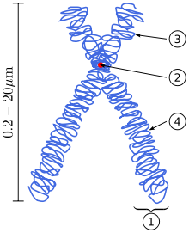
- Sister chromatids are genetically ______________________.
- True or false: Mitosis is a continuous process.
- What are five specific things that occur in a cell during prophase?
- What are two things that occur in a cell during metaphase?
- What are two things that occur in a cell during anaphase?
- What are three things that occur in a cell during telophase?
- What is cytokinesis?
- How is cytokinesis different in plant cells and animal cells?
- Draw a sketch of a cell in interphase and all 4 stages of mitosis. Label: chromosomes, sister chromatids, spindle fibers, centrioles, nuclear envelope, chromatin, centromere, and all phases.
- If an adult cell has “Z” number of chromosomes, how many chromosomes, in terms of Z, will each daughter cell have?
- Label the following diagram:
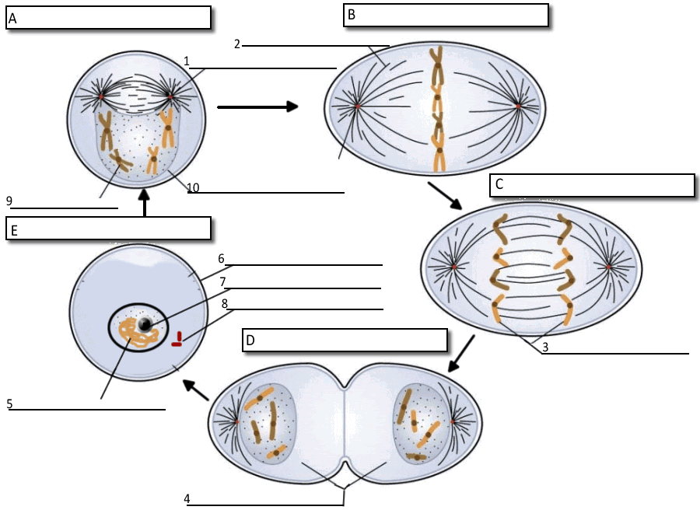
- Label the following stages of the cell cycle on this image of cells in an onion root tip.
Interphase, prophase, metaphase, anaphase, telophase
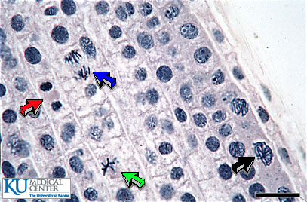
- What stage of the cell cycle are cells in for the longest time?
- What cell of mitosis are cells in for the longest time?
49.) At the end of mitosis, ________ daughter cells have been made from 1 mother cell. The daughter cells are ____________ identical to one another and to the mother cell.
50.) When, in the cell cycle, is DNA replicated?

