Name:________________________

**HSPVA Biology Fetal Pig Dissection: Day 1**

**To complete this dissection lab you will need to do the following:**

1. ***Make sure you define and are familiar with all the* bolded *terms and answer all questions that are asked in each section.***
2. ***Be prepared for a quiz on days 2 and 3 about each day’s learning***
3. ***Always wear your safety gear, clean up after yourself and follow all rules.***

Part A:

# *1.) How old is your pig*? _______________

2.) ***What is the scar that remains on the abdomen called after the cord falls off [hint: you have one]***?_______________________________

*3.) Label the following areas of your pig: dorsal surface, ventral surface****,*** *anterior end****,*** *posterior**end****, head, neck, thorax, abdomen, tail, forelimb, hind limb, and umbilical cord.***

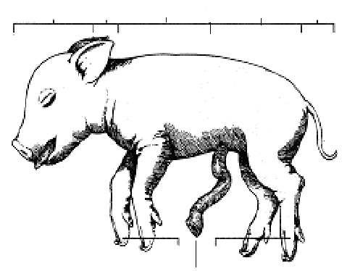

4.) ***How many toes are on the feet***? _________

5.) ***Do they have an odd or******even number of toes***? ________.

***6.) Determine the sex of your pig***: _______________________

***7.)How many papillae are there on your pig***? ____________

8.)***On an average Human***? _______

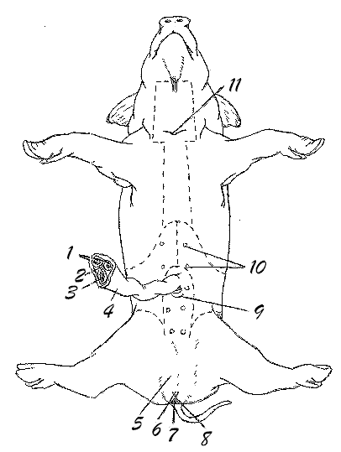**9.)Locate each of the following structures on YOUR and ANOTHER pig of the OPPOSITE GENDER:**

**(check next to the number when you have found it)**

1. [**umbilical arteries**](http://mail.fkchs.sad27.k12.me.us/fkchs/vpig/umbart.htm)
2. [**allantoic duct**](http://mail.fkchs.sad27.k12.me.us/fkchs/vpig/allent.htm) *carries small amounts of nitrogenous waste produced by the kidneys away from the fetus*
3. [**umbilical vein**](http://mail.fkchs.sad27.k12.me.us/fkchs/vpig/umbv.htm)
4. [**umbilical cord**](http://mail.fkchs.sad27.k12.me.us/fkchs/vpig/umbc.htm)
5. [**scrotum**](http://mail.fkchs.sad27.k12.me.us/fkchs/vpig/scrot.htm)(male)
6. [**genital papilla (female)**](http://mail.fkchs.sad27.k12.me.us/fkchs/vpig/genpap.htm) *a projection of tissue dorsal to the urogenital opening*
7. [**anus**](http://mail.fkchs.sad27.k12.me.us/fkchs/vpig/anus.htm)
8. [**urogenital opening (**female**)**](http://mail.fkchs.sad27.k12.me.us/fkchs/vpig/urogenop.htm)
9. **urogenital opening** (male)
10. [**mammary papillae**](http://mail.fkchs.sad27.k12.me.us/fkchs/vpig/mam.htm)
11. tip of **sternum**

***10.)Does the fetal pig have teeth****? ______*

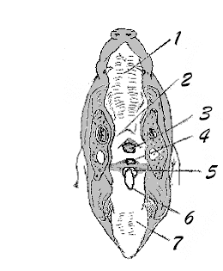*11.)****Are humans born with teeth***? _________

13.) ***Does it seem well developed (has whites, colored iris, eyelashes, eyeball shaped)?*** ____________

***14.) Do you think pigs are born with their eyes open or shut?________***

***15.) Humans*?** ­­­­­­­­­­­­­­­­________________________

***16.) What sense organs are located on the head and in the pig’s mouth?* _____________________________________________________**

**17.) *Compare that to Humans***:

______________________________________________________________________

12.) Also, locate the following structures-check them off when found:

1. [**hard palate**](http://mail.fkchs.sad27.k12.me.us/fkchs/vpig/hpal.htm) **5. glottis**
2. [**soft palate**](http://mail.fkchs.sad27.k12.me.us/fkchs/vpig/spal.htm) **6. epiglottis**
3. [**nasopharynx**](http://mail.fkchs.sad27.k12.me.us/fkchs/vpig/naph.htm) **7. Tongue**
4. [**esophagus**](http://mail.fkchs.sad27.k12.me.us/fkchs/vpig/esoph.htm)

Name:________________________

**HSPVA Biology Fetal Pig Dissection: Day 2**

**To complete this dissection lab you will need to do the following:**

1. ***Make sure you define and are familiar with all the* bolded *terms and answer all questions that are asked in each section.***
2. ***Be prepared for a quiz on days 2 and 3 about each day’s learning***
3. ***Always wear your safety gear, clean up after yourself and follow all rules.***
4. Locate all structures on your pig, and check off the term when you found the structure.

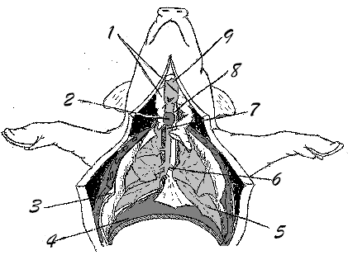

1. [**Thymus**](http://mail.fkchs.sad27.k12.me.us/fkchs/vpig/thym.htm)
2. [**Thyroid**](http://mail.fkchs.sad27.k12.me.us/fkchs/vpig/thyroid.htm)
3. [**Pleural membrane**](http://mail.fkchs.sad27.k12.me.us/fkchs/vpig/plmem.htm)
4. [**Diaphragm**](http://mail.fkchs.sad27.k12.me.us/fkchs/vpig/dia.htm)
5. [**Lungs**](http://mail.fkchs.sad27.k12.me.us/fkchs/vpig/lungs.htm)
6. [**Bronchi**](http://mail.fkchs.sad27.k12.me.us/fkchs/vpig/bronchi.htm)
7. [**Trachea**](http://mail.fkchs.sad27.k12.me.us/fkchs/vpig/trachia.htm)
8. **Esophagus**
9. [**Larynx**](http://mail.fkchs.sad27.k12.me.us/fkchs/vpig/larynx.htm)
10. **Heart** *(not shown due to bronchi in center of chest)*
11. ***What is the function of the cartilage rings*? ________________________________**

_______________________________________________________________________

1. ***What is the function of the epiglottis? _____________***________________________

_______________________________________________________________________

1. ***Why would the ductus arteriosus be important for the fetal pig but not a baby (having been born) pig***?

_____________________________________________________________________

___________________________________________________

5.)Label the parts of the Human respiratory system:

[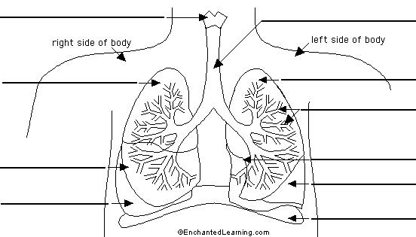](http://www.enchantedlearning.com/label/anatomy.shtml)

***6.)What structure separates the thoracic cavity from the abdominal cavity***? ___________ _______________________________________________________________________

***7.) What two important organs are located in the thoracic cavity***? ___________________ _______________________________________________________________________

***8.)How many lobes of the lungs do the pigs have? How about Humans****? ____________ ______________________________________________________________________*

***9.)Compare and contrast the Trachea and the Esophagus in looks and function. ______ _____________________________________________________________________________________________________________________________________________________________________________________________________________________***

***10.)Name the organs and structures of the respiratory system in order, from the mouth to the lungs***. ______________________________________________________________ ______________________________________________________________________________________________________________________________________________

11.)What happens to the pressure in your thoracic cavity as the diaphragm expands and then contracts. Explain what happens to the air and lungs specifically.___________ _______________________________________________________________________

***12.)Name the blood vessels and heart structures that make up the circulatory system in order, beginning with the superior vena cava and inferior vena cava.*** ______________________________________________________________________________________________________________________________________________

***13.)In what ways do the atria and ventricles differ***? _______________________________ ______________________________________________________________________________________________________________________________________________

***14.)Describe the mesentery, and give its function***. _________________________________ _______________________________________________________________________

***15.)What is the function of the coronary blood vessels***? ____________________________ _______________________________________________________________________

16.) Label the diagram of the heart with the structures that you observed.

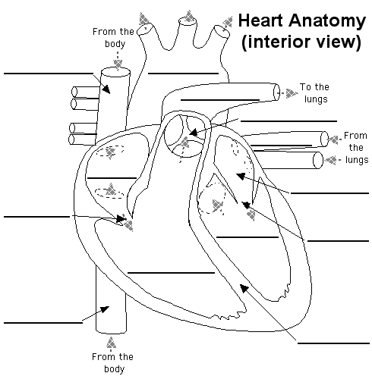

17.) Explain how the blood flows from the heart to the body and back again:

**Fetal Pig Dissection: Day 3** Name: ________________________

1. ***Where does the umbilical vein go?*** _______________________________________________________________________

________________________________________

### *What is a sphincter?* _______________________________________________________

1. *Why is the anterior end of the stomach called the Cardiac stomach?* _______________

________________________________________________________________________

1. *What is the function of the mesentery?* _______________________________________
2. IDENTIFY and CHECK OFF all of the structures below:

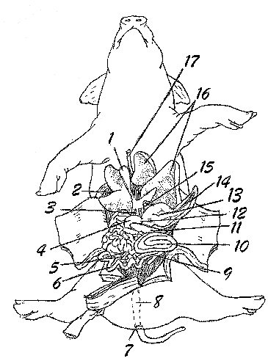

1. [**gall bladder**](http://mail.fkchs.sad27.k12.me.us/fkchs/vpig/gallbl.htm)
2. [**diaphragm**](http://mail.fkchs.sad27.k12.me.us/fkchs/vpig/dia.htm)
3. [**bile duct**](http://mail.fkchs.sad27.k12.me.us/fkchs/vpig/bileduct.htm)
4. [**duodenum**](http://mail.fkchs.sad27.k12.me.us/fkchs/vpig/duod.htm)
5. [**mesentery**](http://mail.fkchs.sad27.k12.me.us/fkchs/vpig/mes.htm)
6. [**small intestine**](http://mail.fkchs.sad27.k12.me.us/fkchs/vpig/smintest.htm)
7. [**anus**](http://mail.fkchs.sad27.k12.me.us/fkchs/vpig/anus.htm)
8. [**rectum**](http://mail.fkchs.sad27.k12.me.us/fkchs/vpig/rectum.htm)
9. [**caecum**](http://mail.fkchs.sad27.k12.me.us/fkchs/vpig/cecum.htm)
10. [**colon**](http://mail.fkchs.sad27.k12.me.us/fkchs/vpig/colon.htm)
11. [**pancreas**](http://mail.fkchs.sad27.k12.me.us/fkchs/vpig/pancreas.htm)
12. [**pyloric sphincter**](http://mail.fkchs.sad27.k12.me.us/fkchs/vpig/pylosph.htm)*a hard ring of smooth muscle; creates a boundary between the stomach and the small intestine*
13. [**stomach**](http://mail.fkchs.sad27.k12.me.us/fkchs/vpig/stomach.htm)
14. [**spleen**](http://mail.fkchs.sad27.k12.me.us/fkchs/vpig/spleen.htm)
15. [**esophagus**](http://mail.fkchs.sad27.k12.me.us/fkchs/vpig/esoph.htm)
16. [**retracted liver lobes**](http://mail.fkchs.sad27.k12.me.us/fkchs/vpig/liver.htm)*produces bile*
17. [**umbilical vein**](http://mail.fkchs.sad27.k12.me.us/fkchs/vpig/umbv.htm)
18. ***Why does the esophagus appear to be short?* _________________________________**

**__________________________________________________________________________**

1. ***What system does the diaphragm belong to in the body*?**

**__________________________________________________________________**

1. ***To what system does the spleen belong***? _______________________________
2. ***What is the function of the spleen*? ________________________________________**
3. **Label the parts of the Human Digestive system:**

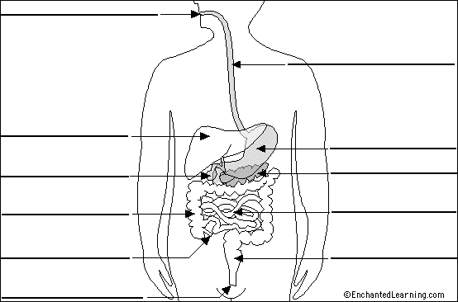

1. ***Name the organs and structures of the digestive system in the order that food moves through them.*** _________________________________________________________ ______________________________________________________________________________________________________________________________________________
2. ***How many lobes does the liver have in the pig and in the human***?

_______________________________________________________________________

1. ***What is the function of the umbilical cord***?

______________________________________________________________________

1. For the next section, you will need to observe your pig and another person’s pig so that you can see both sexes of fetal pig. You will have to recognize both reproductive organs on either sex of pig. IDENTIFY AND CHECK OFF ALL OF THE FOLLOWING STRUCTURES:



1. [**Kidney**](http://mail.fkchs.sad27.k12.me.us/fkchs/vpig/kidney.htm)
2. **Genital artery**
3. [**Ureter**](http://mail.fkchs.sad27.k12.me.us/fkchs/vpig/ureter.htm)
4. [**Umbilical arteries**](http://mail.fkchs.sad27.k12.me.us/fkchs/vpig/umbart.htm)
5. [**Cervix**](http://mail.fkchs.sad27.k12.me.us/fkchs/vpig/cervix.htm)
6. [**Urinary bladder**](http://mail.fkchs.sad27.k12.me.us/fkchs/vpig/ublad.htm)
7. [**Urethra**](http://mail.fkchs.sad27.k12.me.us/fkchs/vpig/urethra.htm)
8. [**Urogenital opening**](http://mail.fkchs.sad27.k12.me.us/fkchs/vpig/urogenop.htm)
9. [**Urogenital sinus**](http://mail.fkchs.sad27.k12.me.us/fkchs/vpig/urosinus.htm)
10. [**Vagina (may be cut open)**](http://mail.fkchs.sad27.k12.me.us/fkchs/vpig/vagina.htm)
11. **Uterine horn**
12. [**Oviduct**](http://mail.fkchs.sad27.k12.me.us/fkchs/vpig/oviduct.htm)
13. [**Ovary**](http://mail.fkchs.sad27.k12.me.us/fkchs/vpig/ovary.htm)
14. [**Renal artery**](http://mail.fkchs.sad27.k12.me.us/fkchs/vpig/renalart.htm)
15. [**Renal vein**](http://mail.fkchs.sad27.k12.me.us/fkchs/vpig/renalv.htm)

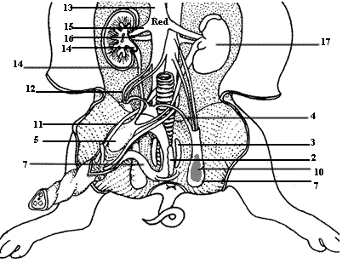

#### The Male Reproductive System

1. [**Adrenal gland**](http://mail.fkchs.sad27.k12.me.us/fkchs/vpig/adgland.htm)
2. [**Seminal vesicle**](http://mail.fkchs.sad27.k12.me.us/fkchs/vpig/semves.htm)
3. **Prostate location**
4. [**Inguinal canal**](http://mail.fkchs.sad27.k12.me.us/fkchs/vpig/inguin.htm)
5. [**Urinary bladder**](http://mail.fkchs.sad27.k12.me.us/fkchs/vpig/ublad.htm)
6. **Urogenital opening**
7. [**Urethra**](http://mail.fkchs.sad27.k12.me.us/fkchs/vpig/urethra.htm)
8. [**Bulbourethral (Cowper's) gland**](http://mail.fkchs.sad27.k12.me.us/fkchs/vpig/cowper.htm)
9. [**Epididymis**](http://mail.fkchs.sad27.k12.me.us/fkchs/vpig/epi.htm)
10. [**Testis**](http://mail.fkchs.sad27.k12.me.us/fkchs/vpig/testis.htm)
11. [**Umbilical arteries**](http://mail.fkchs.sad27.k12.me.us/fkchs/vpig/umbart.htm)
12. **Genital artery**
13. [**Dorsal aorta**](http://mail.fkchs.sad27.k12.me.us/fkchs/vpig/aorta.htm)
14. [**Ureter**](http://mail.fkchs.sad27.k12.me.us/fkchs/vpig/ureter.htm)
15. [**Renal artery**](http://mail.fkchs.sad27.k12.me.us/fkchs/vpig/renalart.htm)
16. [**Renal vein**](http://mail.fkchs.sad27.k12.me.us/fkchs/vpig/renalv.htm)
17. [**Kidney**](http://mail.fkchs.sad27.k12.me.us/fkchs/vpig/kidney.htm)
18. * [**Penis**](http://mail.fkchs.sad27.k12.me.us/fkchs/vpig/penis.htm) **–** *located below the umbilical cord on the belly. Find it there.*

15.The male reproductive system – depending on the age of the male fetus you will find the oval-shaped testes either in the abdominal cavity or inside the scrotal sacs at the posterior of the pig. On each testis, find the coiled epididymis. ***What is the function of the epididymis***?

_________________________________________________________

1. The **vas deferens** carry the sperm from the epididymis to the urethra. Follow the urethra to the penis, a muscular tube carrying both reproductive cells and liquid wastes out of the body. The urethra goes all the way through the inside of the penis.
2. ***Does a human need both kidneys to survive? Explain.***
3. ***Name the major mammalian characteristics that are exhibited by the fetal pig***.

19.