How to access the Biology textbook (Miller & Levine Biology)
- Log on to the HUB (also known as itslearning): https://houston.itslearning.com/index.aspx?SessionExpired=0
- You will see this:
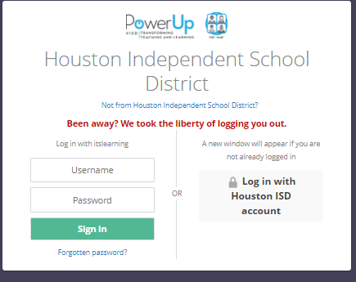

Click on “Log in with Houston ISD account”
- You will see a page similar to this:
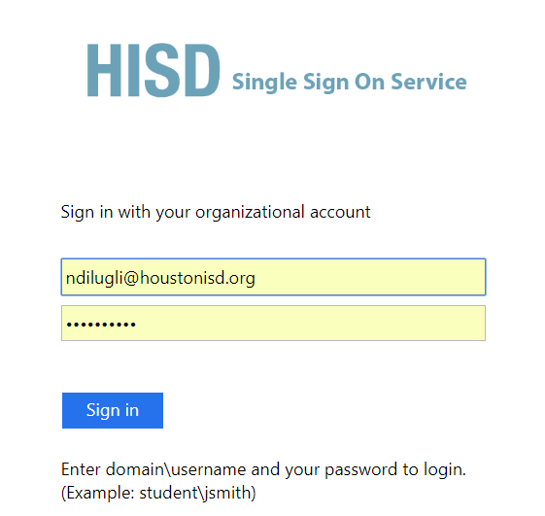
Sign in like you sign in to your laptop.

- You will see a page similar to this:
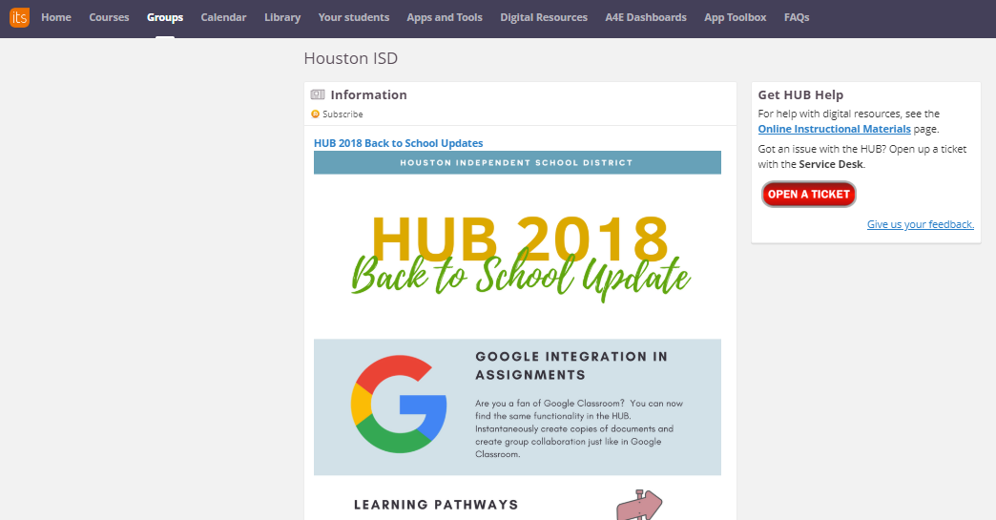
Click on “Digital Resources” at the top.
- You will see a screen like this:
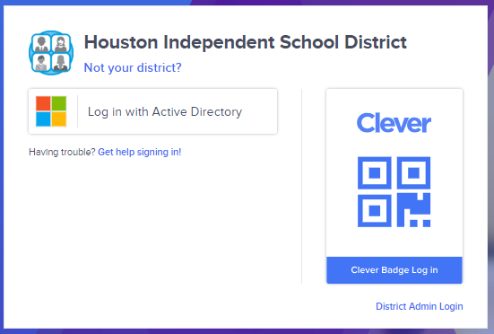
Click: “Log in with Active Directory”

- You will see a screen like this:
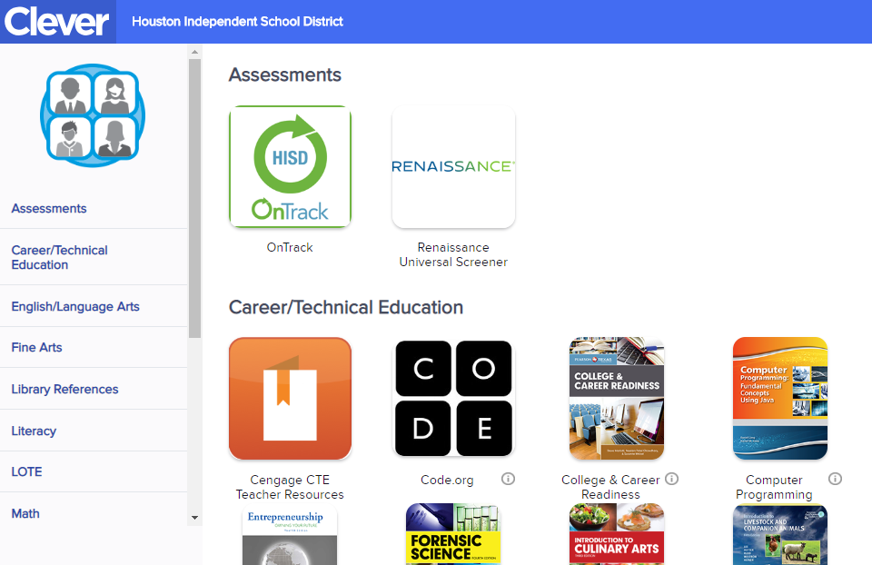
Scroll down on the left and click on “Science”
- Click on this icon-this is your Biology book!
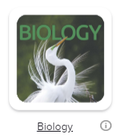
- Check to see if you can access the textbook from home. You may not be able to-let me know this the next time we meet as a class.

