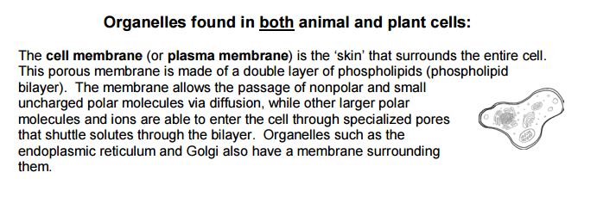
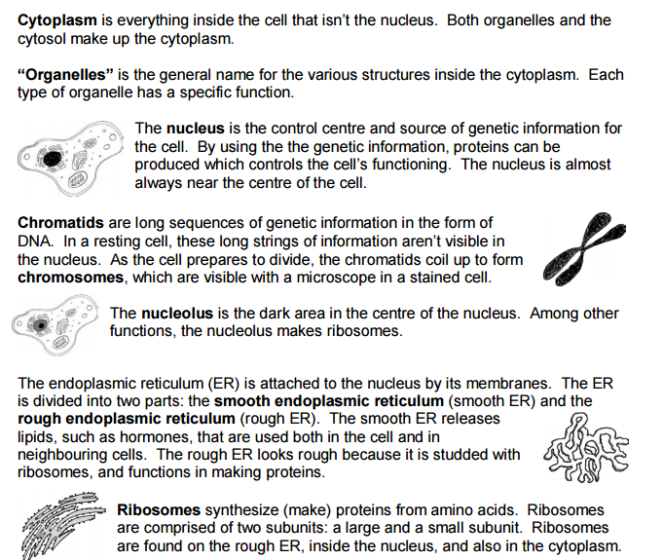
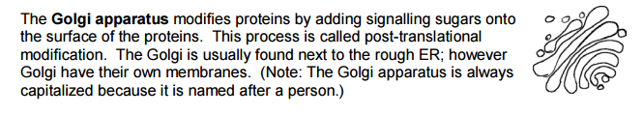
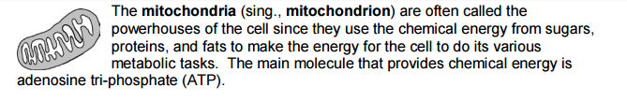
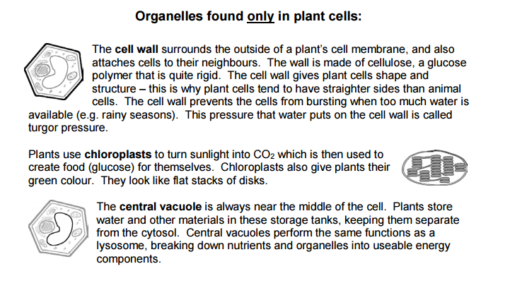

Review Questions:
- Match the cell parts in the first column with the descriptions in the second column. Each cell part and description should be used only once.
Cell Structures Description
- Ribosome _____ Makes proteins
- Golgi apparatus _____ Made of membrane and contains DNA
- Cell membrane _____ Stores water for plant and animal cells
- Endoplasmic reticulum _____ Controls passage of molecules in and out of the cell
- Mitochondria _____ Converts solar energy to useable cell energy
- Nucleus _____ Provides shape and support to plant cells
- Cell wall _____ Modifies and transports proteins
- Chloroplast _____ Converts food into energy for the cell
- Vacuole _____ Stores genetic information and is found in the nucleus
- Chromosome/chromatin _____ Transports proteins through the cell

- Label the cells below with the structured listed above. Can you tell the difference between a plant and an animal cell?

